BHARAT SHRINIVAS HEGDE
CSE 3D
1BM25CS413-T (Diploma)

LAB PROGRAM - 4A
WAP to Implement Singly Linked List with following operations
a) Create a linked list.
b) Insertion of a node at first position.
c)at any position
d)at end of list.
Display the contents of the linked list.

Code:
#include <stdio.h>
#include <stdlib.h>

struct Node {
int data;
struct Node *next;
};

struct Node *head = NULL;

// Function to create a new node
struct Node* createNode(int data) {
struct Node* newNode = (struct Node*)malloc(sizeof(struct Node));
newNode->data = data;
newNode->next = NULL;
return newNode;
}

// Function to create initial linked list
void createList(int n) {
struct Node *newNode, *temp;
int data, i;

if (n <= 0) {
printf("Number of nodes should be greater than 0.\n");
return;
}

for (i = 1; i <= n; i++) {
printf("Enter data for node %d: ", i);
scanf("%d", &data);

newNode = createNode(data);

if (head == NULL) {
head = newNode;
temp = head;
} else {
temp->next = newNode;
temp = newNode;
}
}
printf("\nLinked list created successfully.\n");
}

// Insert at beginning
void insertAtBeginning(int data) {
struct Node* newNode = createNode(data);
newNode->next = head;
head = newNode;
printf("Node inserted at beginning.\n");
}

// Insert at end
void insertAtEnd(int data) {
struct Node* newNode = createNode(data);
if (head == NULL) {
head = newNode;
return;
}
struct Node* temp = head;
while (temp->next != NULL)
temp = temp->next;
temp->next = newNode;
printf("Node inserted at end.\n");
}

// Insert at a specific position
void insertAtPosition(int data, int pos) {
struct Node* newNode = createNode(data);

if (pos == 1) {
newNode->next = head;
head = newNode;
printf("Node inserted at position %d.\n", pos);
return;
}

struct Node* temp = head;
for (int i = 1; i < pos - 1 && temp != NULL; i++)
temp = temp->next;

if (temp == NULL) {
printf("Position out of range!\n");
free(newNode);
return;
}

newNode->next = temp->next;
temp->next = newNode;
printf("Node inserted at position %d.\n", pos);
}

// Display the linked list
void displayList() {
if (head == NULL) {
printf("List is empty.\n");
return;
}
struct Node* temp = head;
printf("Linked List: ");
while (temp != NULL) {
printf("%d -> ", temp->data);
temp = temp->next;
}
printf("NULL\n");
}

// Main function
int main() {
int choice, data, pos, n;

// Step 1: Always create a list first
printf("Enter the number of nodes : ");
scanf("%d", &n);
createList(n);

// Step 2: Then show the operations menu
printf("\n--- Singly Linked List Menu ---\n");
printf("1. Insert at Beginning\n");
printf("2. Insert at End\n");
printf("3. Insert at Any Position\n");
printf("4. Display List\n");
printf("5. Exit\n");

while (1) {
printf("\nEnter your choice: ");
scanf("%d", &choice);

switch (choice) {
case 1:
printf("Enter data: ");
scanf("%d", &data);
insertAtBeginning(data);
break;
case 2:
printf("Enter data: ");
scanf("%d", &data);
insertAtEnd(data);
break;
case 3:
printf("Enter data and position: ");
scanf("%d %d", &data, &pos);
insertAtPosition(data, pos);
break;
case 4:
displayList();
break;
case 5:
printf("Exiting...\n");
exit(0);
default:
printf("Invalid choice! Try again.\n");
}
}

return 0;
}

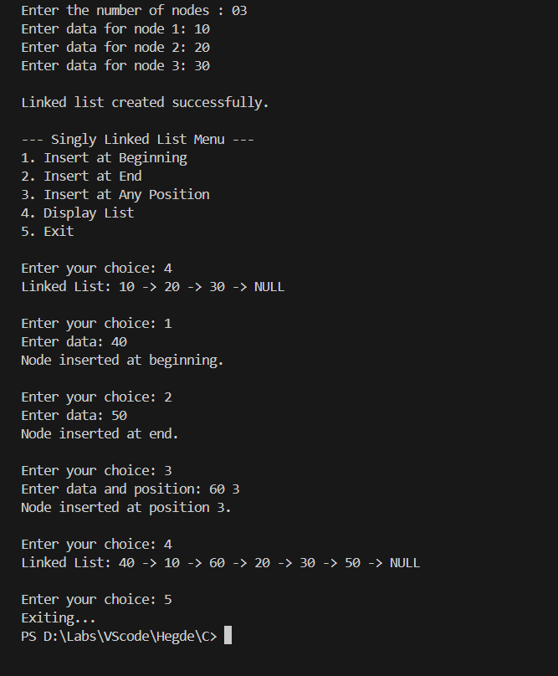
Output:

